1. **Create Ec2 instance –**

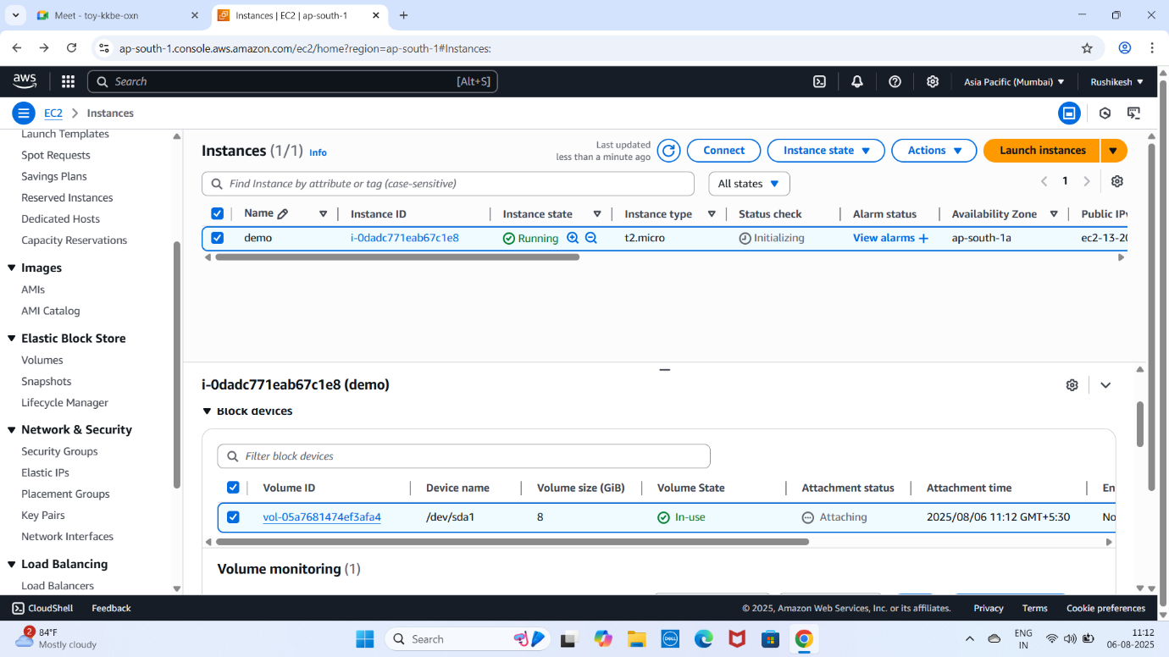

1. **By default you will get EBS**

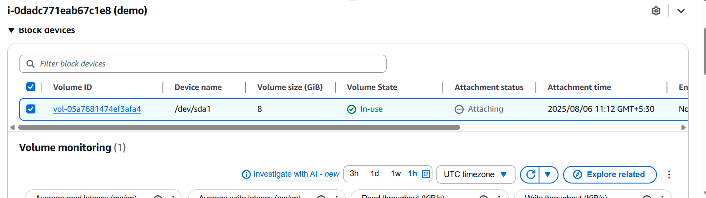

1. **Create a New EBS (new)**

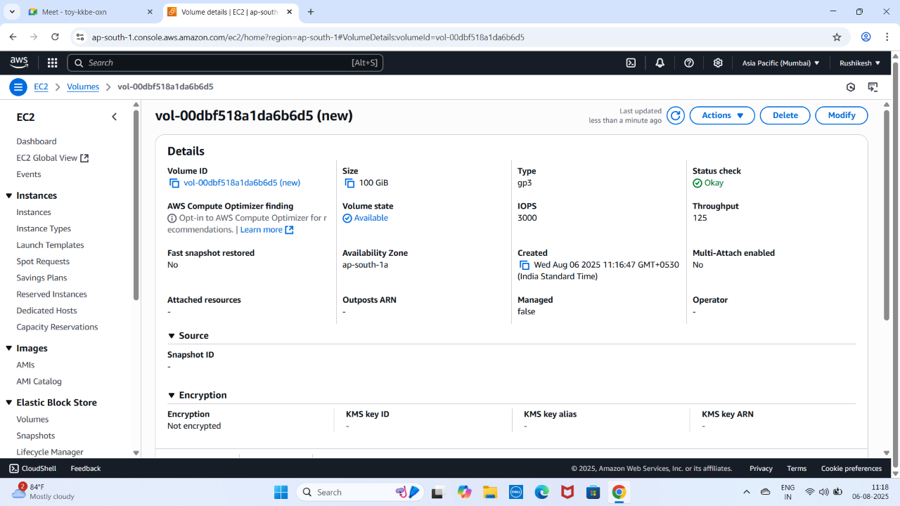

1. **Create a snapshot of New EBS**

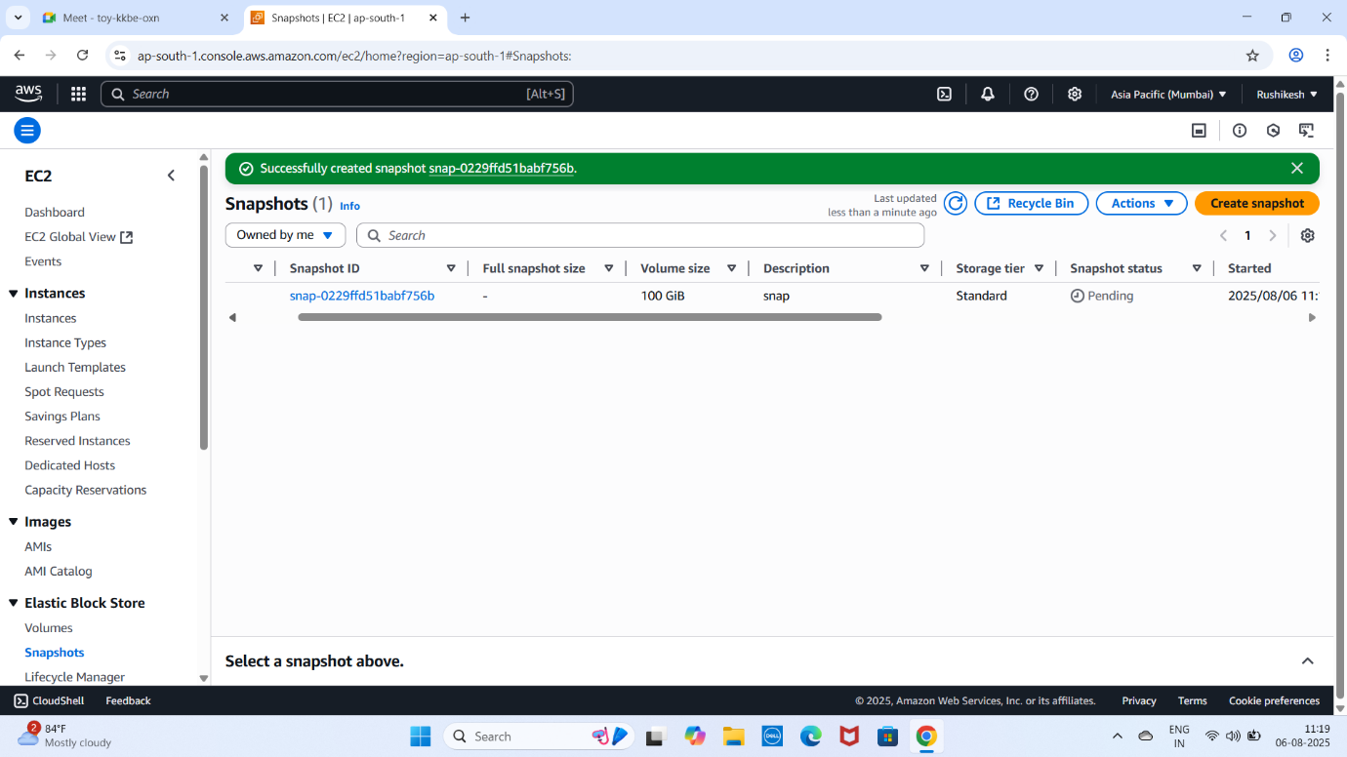

1. **Create a recycle bin for new** **EBS**

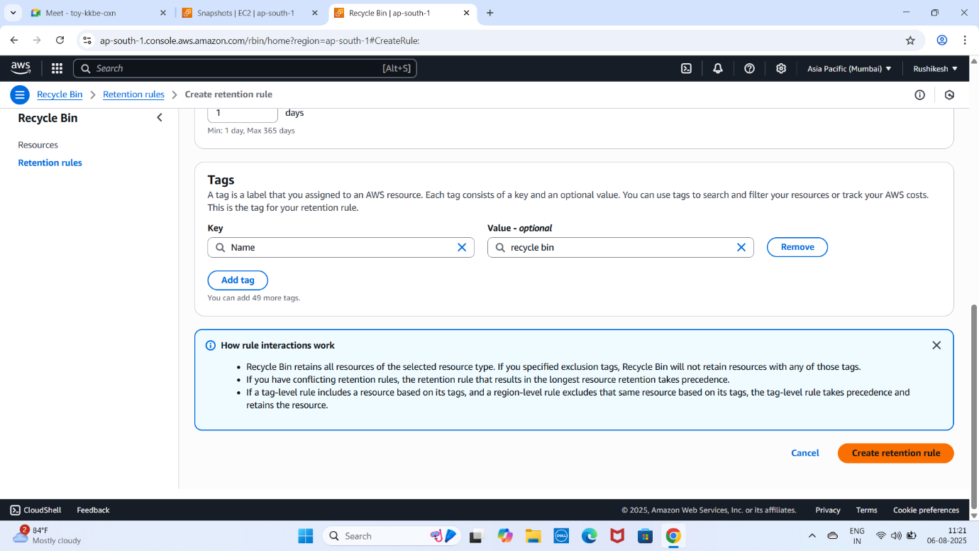

1. **Recycle bin created**

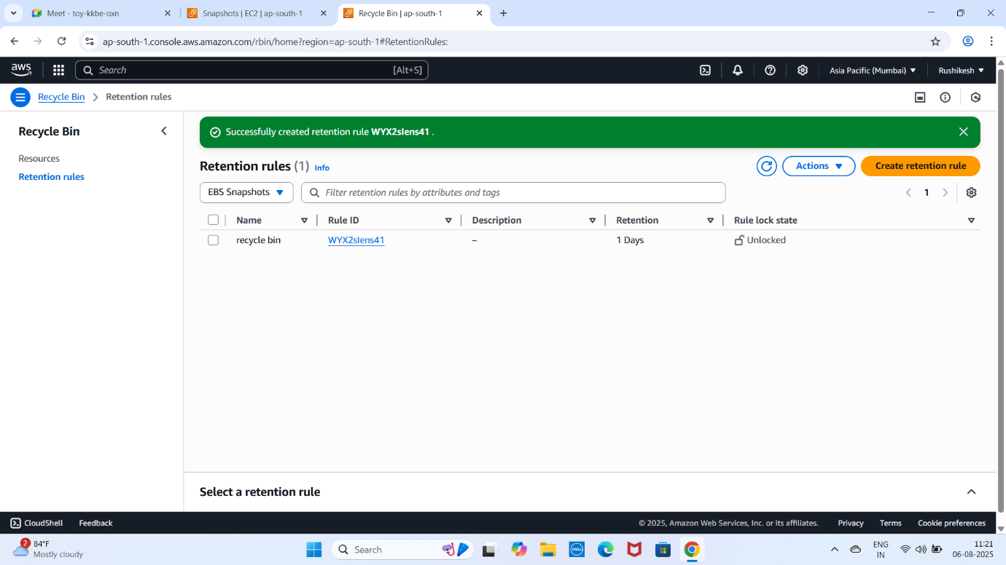

* If we directly terminate instance
* By default, EBS will delete
* But new will be there
* If we accidently delete snapshot
* The back up of snapshot will be there in recycle bin
* We can recover snapshot from recycle bin